27th November 2018

**YOKOHAMA Spain confirms 2nd participation at the DAKAR**

YOKOHAMA has been part of the Dakar 2018 challenge along with the SsangYong Spain Team and its Tivoli DKR vehicle, which, driven on the spectacular "GEOLANDAR M/T G003" managed to conclude the tough race in South America, on a meritorious position in its 40th edition.

Next year, the SsangYong team will return to take part in the 41st edition of the Dakar, again led by Óscar Fuertes and his co-driver, Diego Vallejo, in a demanding race that will take place from January 6th to the 17th, exclusively in Peru.

The race will start and end in the city of Lima. Throughout the ten stages, the teams will travel a total of 5,000 kilometres, of which 70% will be sand and dunes.

For 2019, the team sponsored by YOKOHAMA will have a new vehicle, the SsanYong Rexton DKR, which will be equipped with YOKOHAMA GEOLANDAR M/T G003 tyres, in 37x12.5 R 17 size.

The vehicle has been developed entirely in Spain and has a 6.2Litres V8 petrol engine especially prepared for the competition and offers 450hp.

The "GEOLANDAR M/T G003" is the new off-road tyre of the GEOLANDAR range for SUVs and Pick Ups from the Japanese premium tyre manufacturer YOKOHAMA. It provides extreme performance in off-road scenarios, from mud to rocks, dirt and gravel. The tread of the "GEOLANDAR M/T G003" includes a large mesh of blocks and sequential lamellae that helps the tyre to achieve excellent traction on various off-road surfaces. In addition, the "GEOLANDAR M/T G003" has a thickened sidewall with an aggressive block on the top side of the tyre. This block increases the resistance to cuts and wear.

"This is an important issue, because compared to other prestigious brands, our tyre is one of the few that have not been punctured and of which fewer units have been needed to finish the race, this year." Added Víctor Manuel Cañizares, Director and Vice President of Sales & Marketing for Yokohama Iberia. “In the last edition, as we heard from Óscar Fuertes less than 50% of the competitors finished, which means that our tyre contributed to finish the race.” he concluded.

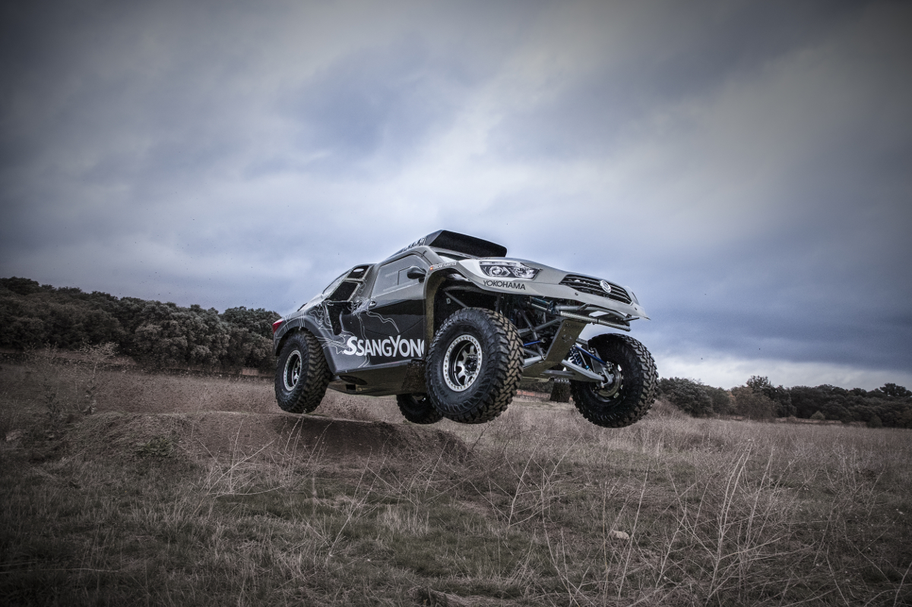

*SsanYong Rexton DKR on YOKOHAMA Geolandar MT G003 for Dakar Rally (1)*

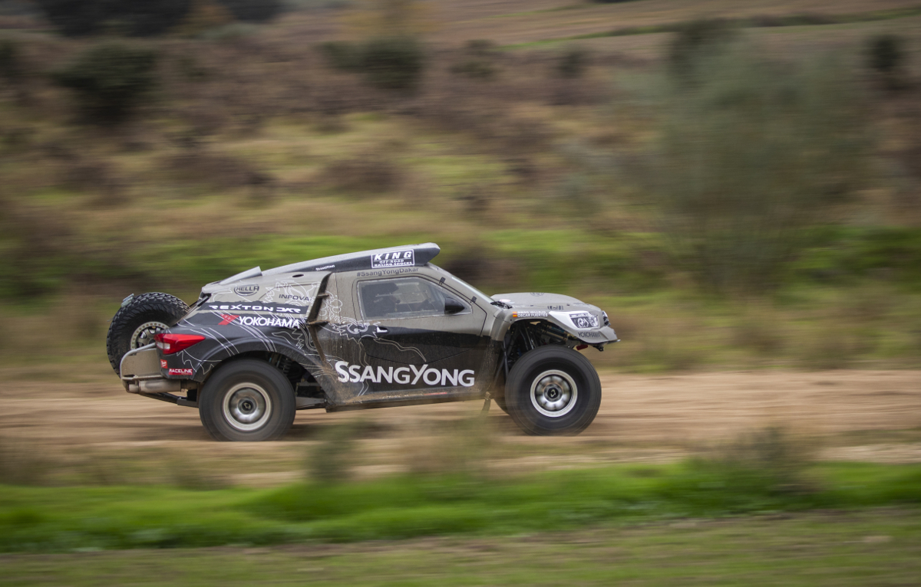

*SsanYong Rexton DKR on YOKOHAMA Geolandar MT G003 for Dakar Rally (2)*

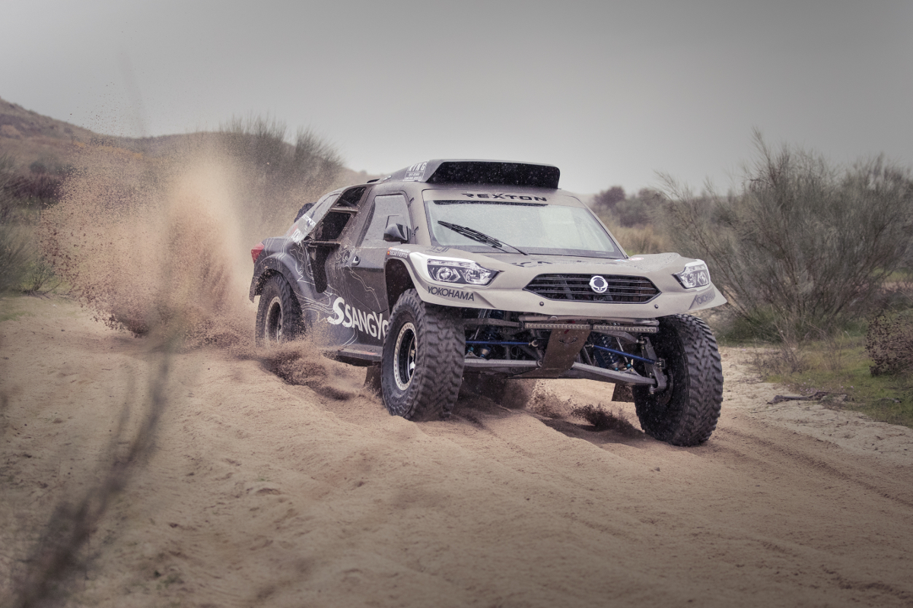

*SsanYong Rexton DKR on YOKOHAMA Geolandar MT G003 for Dakar Rally (3)*